LAB 11 TASK FOR PROGRAMMING FUNDAMENTAL

Submitted By:ALI ASAD

Submitted To: SIR SHAHZAD

Q1:

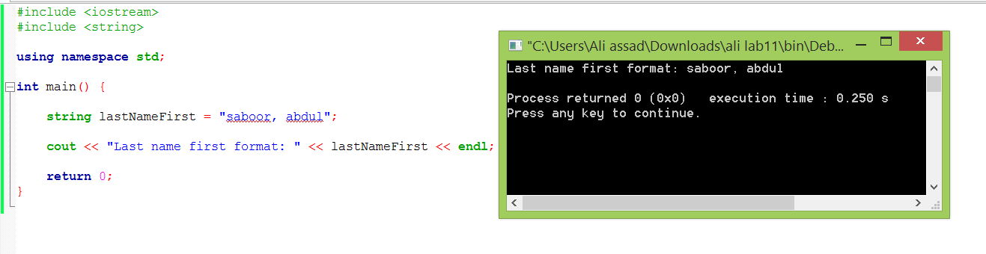

Q2:

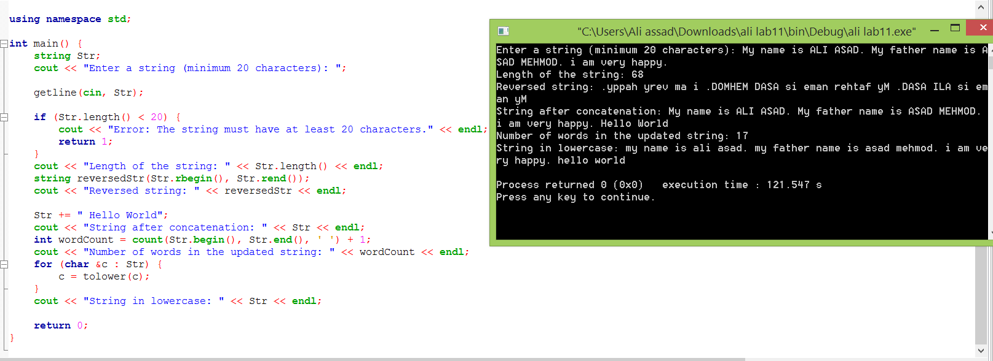

Q3:

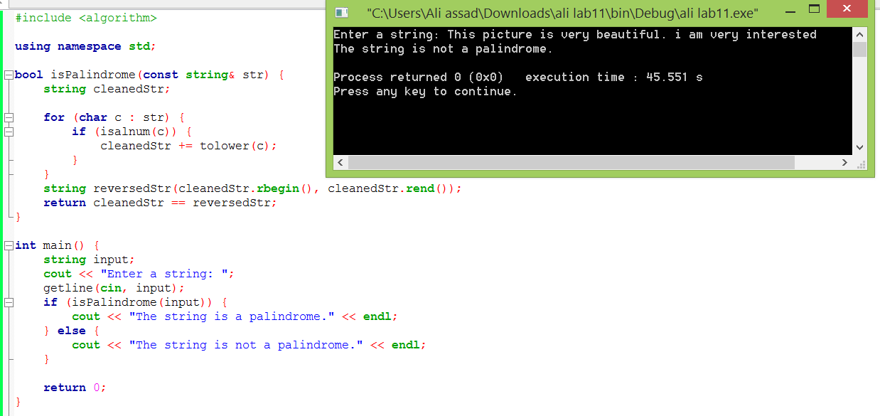

Q4:

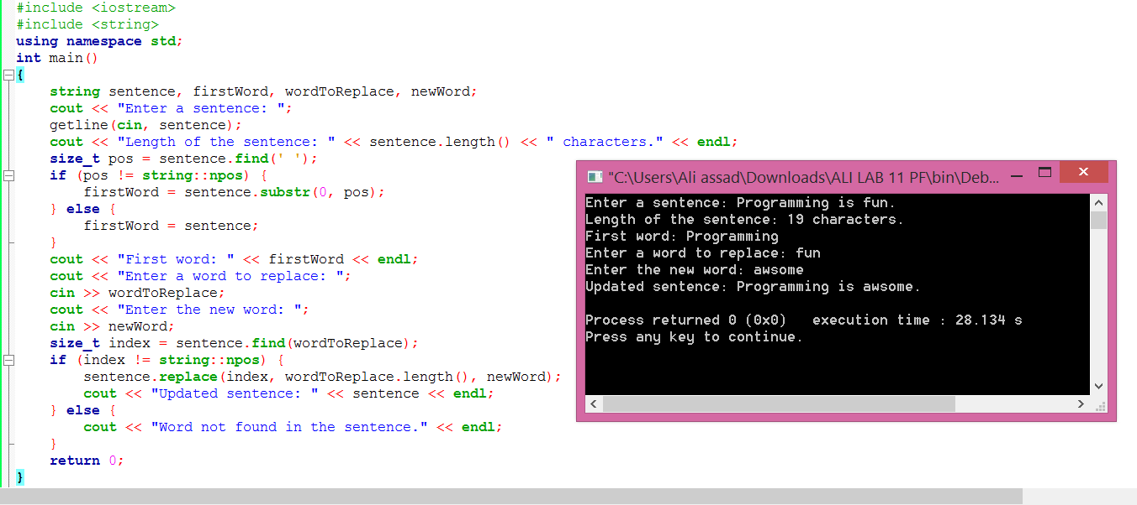

Q5:

